Project: EduLink Student & Course Management System

Phase 5: Apex Programming (Developer)

Goal of this Phase
The goal of this phase was to implement core backend logic using Apex to support the EduLink system's student and course management functionalities. This involved creating classes with business logic, automating processes with triggers, handling data operations safely, and ensuring code reliability with test classes.
Of course. Based on our entire conversation, the Apex classes you've created, and the reference document you provided, here is a summary document for your Phase 5.
This document accurately reflects the work you have completed so far.

Project: EduLink Student & Course Management System

Phase 5: Apex Programming (Developer)

Goal of this Phase
The goal of this phase was to implement core backend logic using Apex to support the EduLink system's student and course management functionalities. This involved creating classes with business logic, automating processes with triggers, handling data operations safely, and ensuring code reliability with test classes.

1. Classes & Objects
Several Apex classes were created to encapsulate business logic and manage data operations. Key classes include:
- StudentQueries: A utility class to centralize common SOQL queries for retrieving student and course data.
- EnrollmentManager: A service class to handle the logic for enrolling students in courses in bulk.
- SafeDataManager: A class designed to perform DML operations (inserts, updates) safely using exception handling.
- EduLinkHelper: A simple utility class with helper methods for calculations and grading logic.
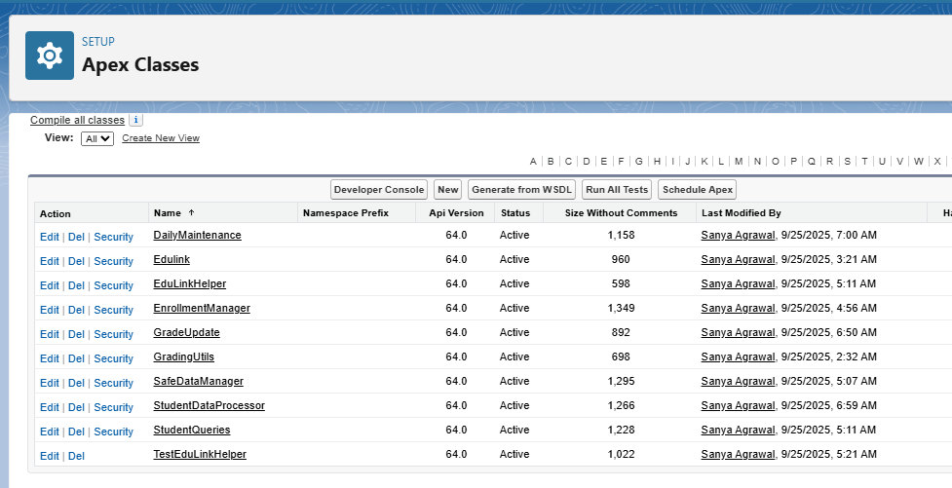

Scenario 1: Testing the calculateGPA Method
For this an apex class named GradingUtils was created
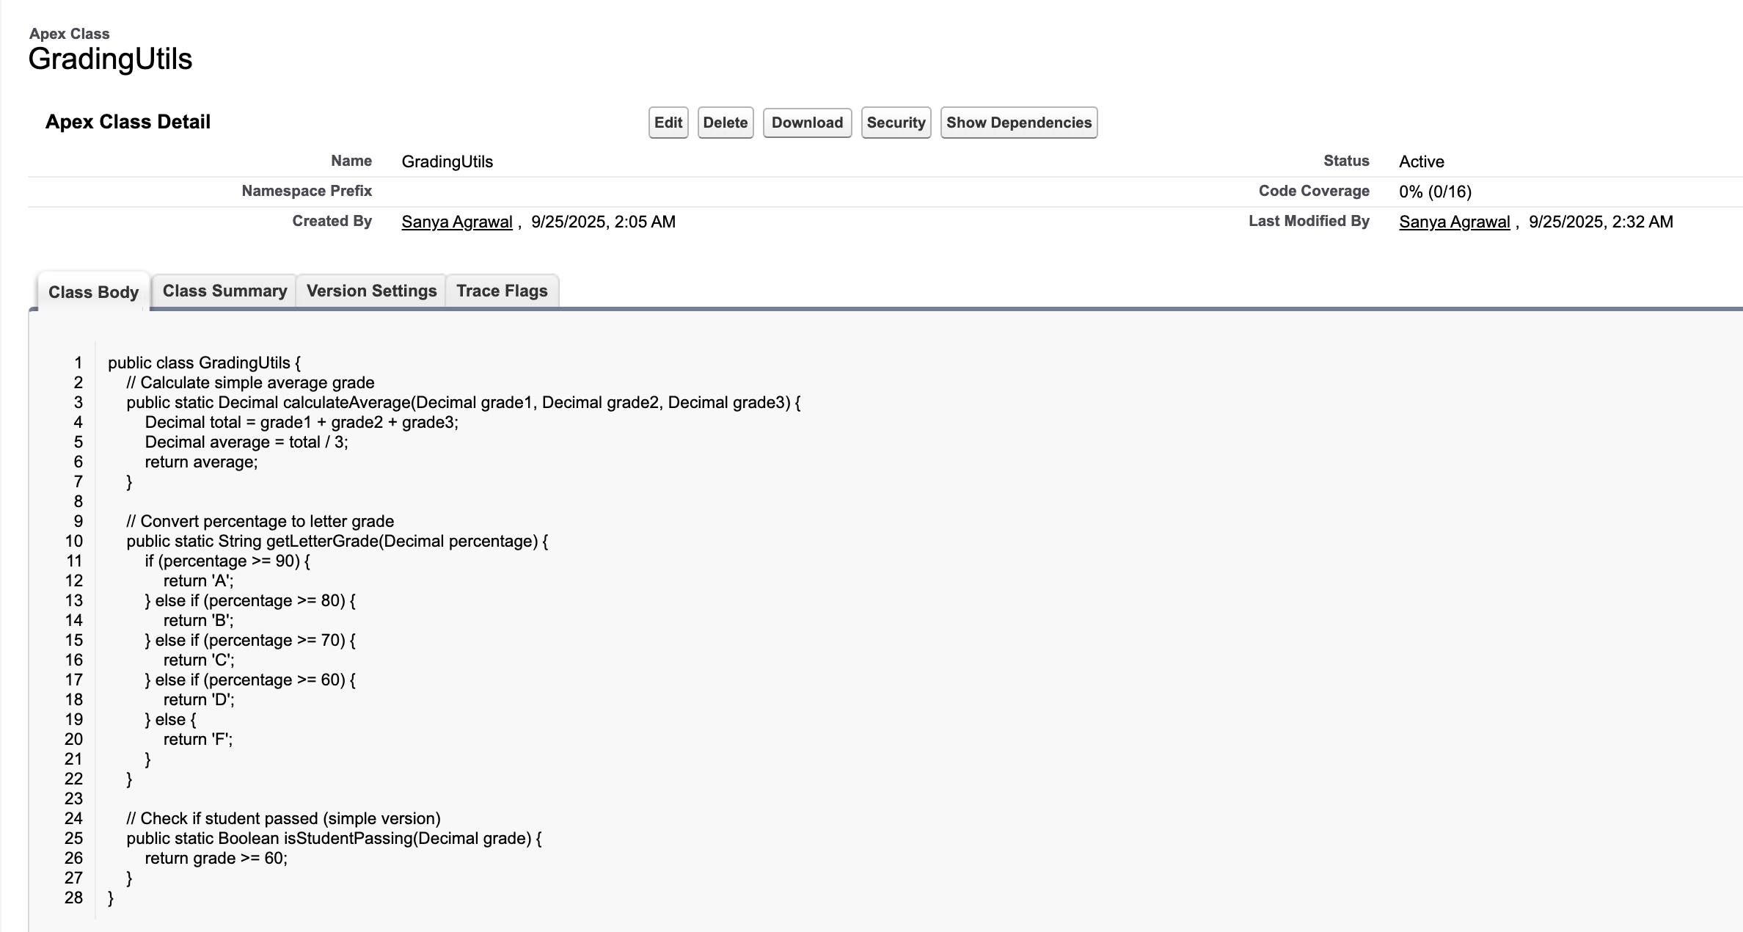
// 1. Find progress records for a specific student enrollment.
List<Progress__c> progressList = [SELECT Id, Points_Earned__c, Assignment__r.Max_Points__c
FROM Progress__c
WHERE Enrollment__r.Student__r.Name = Arjun Patel'
LIMIT 10];
if (!progressList.isEmpty()) {
Decimal studentGPA = Edulink.calculateGPA(progressList);
System.debug('The calculated GPA is: ' + studentGPA);
} else {
System.debug('No progress records found for that student.');
}
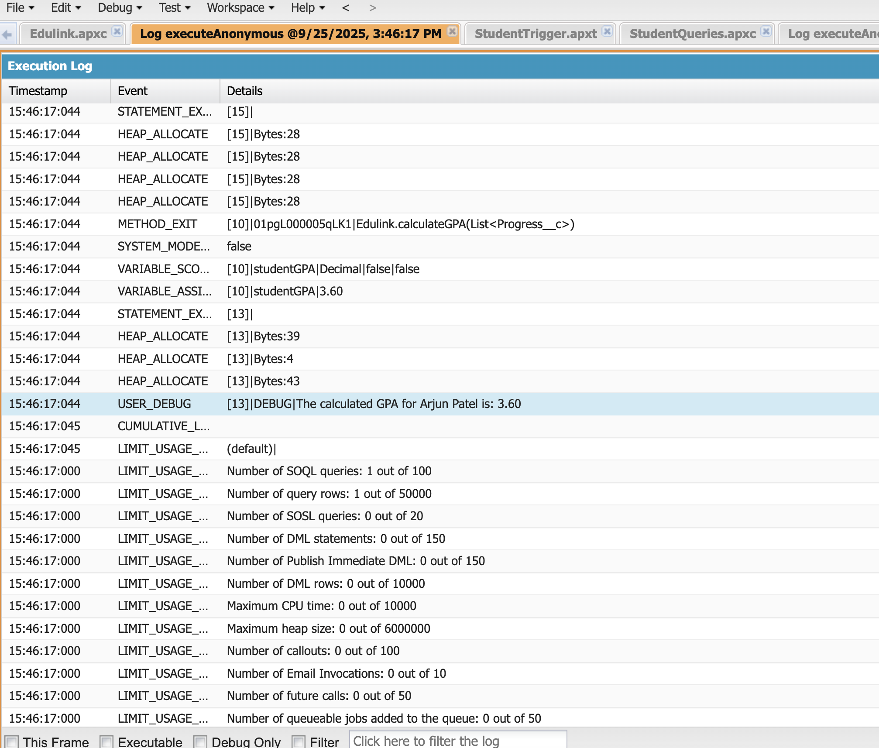

2. Apex Triggers (Before/After Insert/Update/Delete)
A trigger was implemented on the Contact object to automate tasks related to new students.
- StudentTrigger: This trigger fires after insert on Contact records. Its purpose is to automatically create a "Welcome New Student" Task and assign it to the new student's record owner, ensuring prompt follow-up.
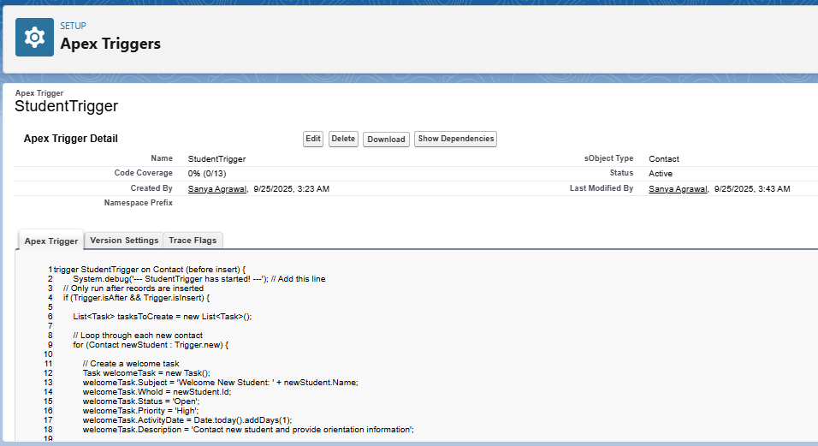

3. Trigger Design Pattern
A formal trigger design pattern, such as a handler class, was not implemented in this phase. The logic for the StudentTrigger resides directly within the trigger file itself. This was suitable for the simple, single-purpose automation created.

4. SOQL
- SOQL: SOQL was used extensively across multiple classes (StudentQueries, EnrollmentManager, GradeUpdateBatch) to select, filter, and retrieve records from custom and standard objects.
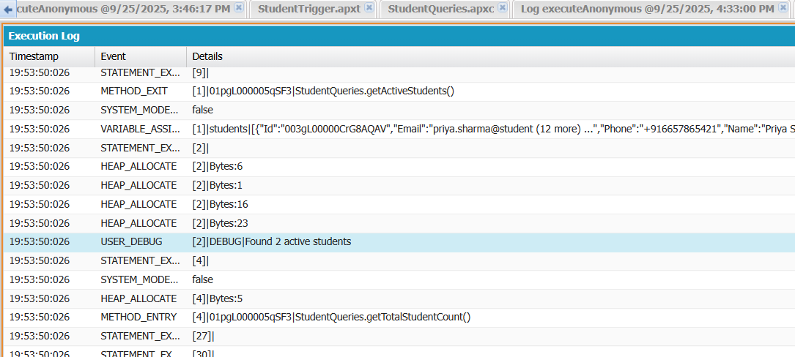
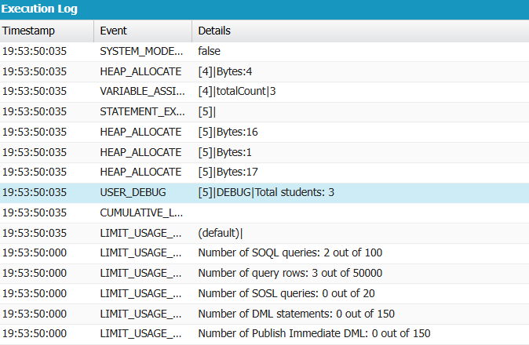

5. Collections (List, Set, Map)
Collections were used to handle records in a bulk-safe manner.
- List: List<Contact>, List<Id>, and List<Enrollment__c> were used to query, process, and insert multiple records at once.
- Map: A Map<String, List<Contact>> was used in EnrollmentManager to efficiently group students by their status field for reporting or summary purposes.
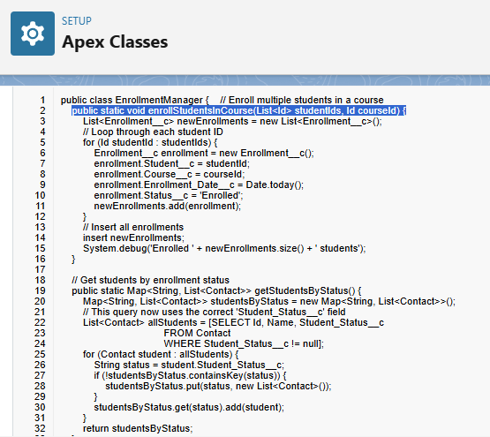

6. Control Statements Batch Apex
Standard control statements were used to direct the flow of logic.
- If-Else: Used in SafeDataManager for input validation and in EnrollmentManager to check if collections were empty before processing.
- For Loops: Used to iterate over lists of records for processing in triggers and service classes
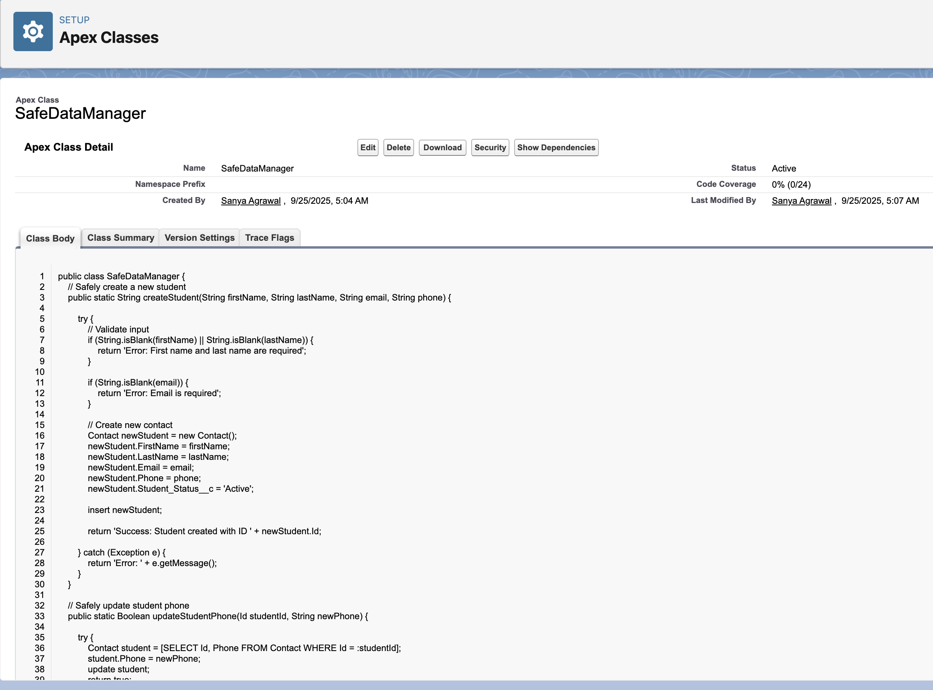

7. Batch Apex
A batch class was created to handle potentially large-scale data updates.
- GradeUpdateBatch: This class implements the Database.Batchable interface to find all "Active" enrollments with a blank final grade and update them to "In Progress". The job was executed and monitored via the Apex Jobs page in Setup.
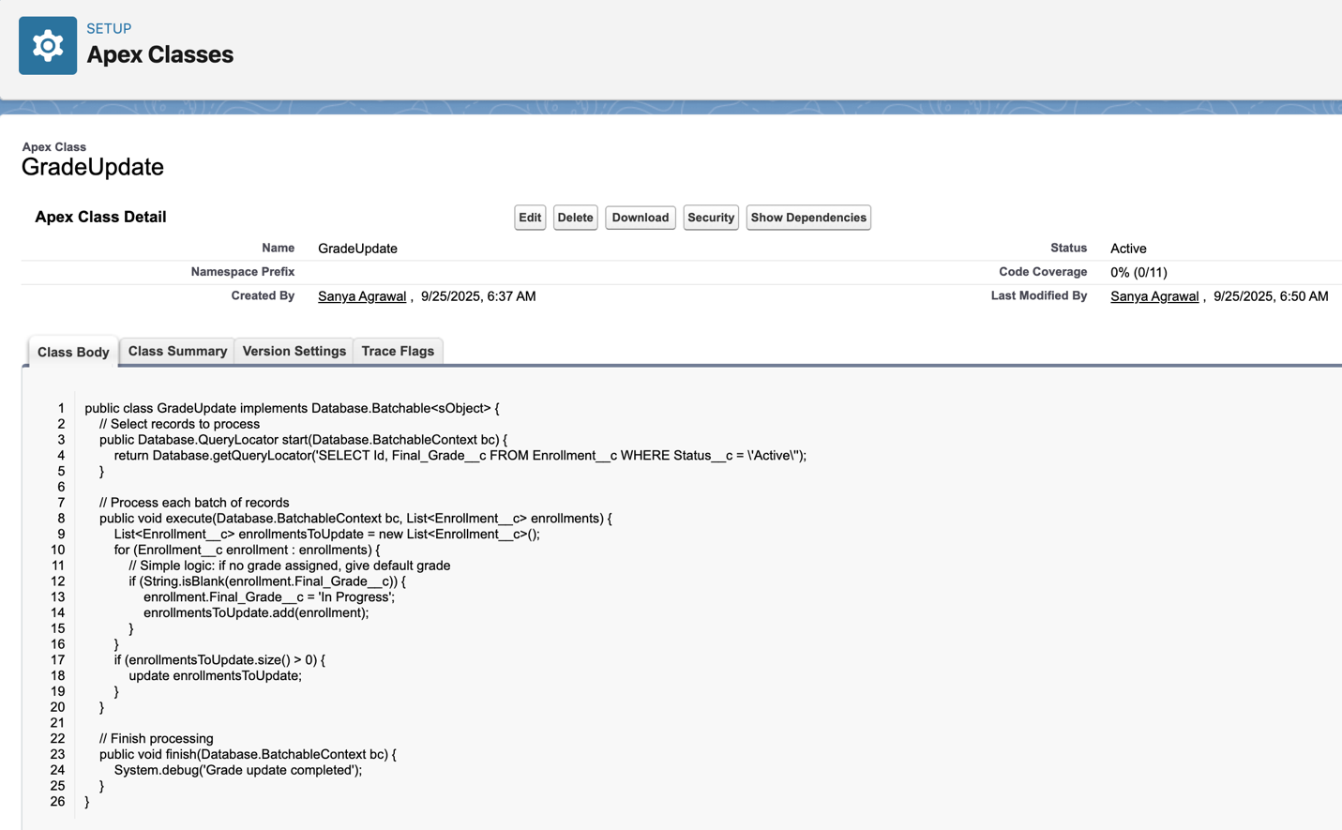

8. Exception Handling
Exception handling was implemented to make DML operations more robust.
- The SafeDataManager class uses try-catch blocks to gracefully handle potential DML exceptions (e.g., errors from validation rules) and return user-friendly error messages instead of crashing.
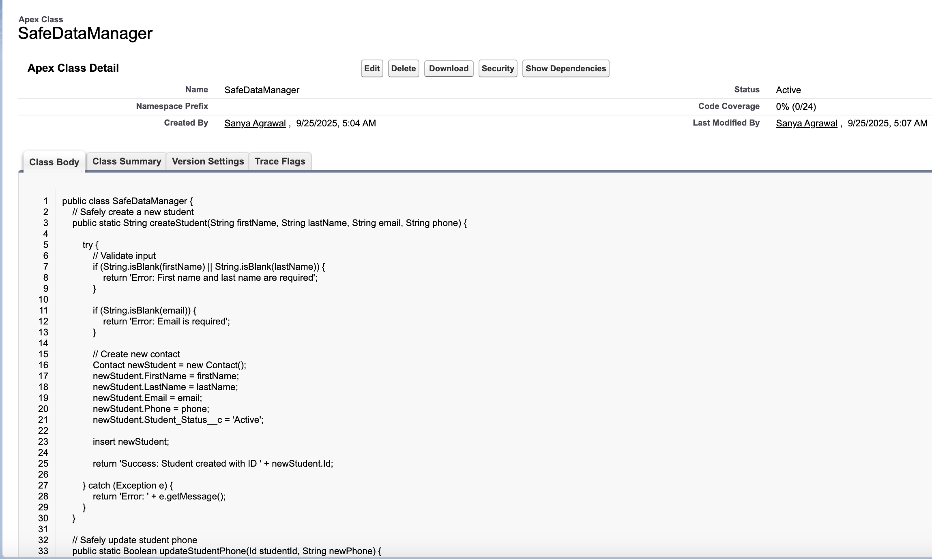

9. Test Classes
A test class was created to ensure code quality and verify business logic.
- TestEduLinkHelper: This class uses the @isTest annotation and System.assertEquals() methods to validate the outputs of the EduLinkHelper class, confirming its reliability and achieving code coverage.

10. Asynchronous Processing
- Batch Apex was the primary method of asynchronous processing implemented and tested in this phase.

